Faculty of Engineering, Applied Sciences, and Technology
Lab Project

Course Code: BCS202 | Course Name: Introduction to Computing Science II
Date of Submission: 22nd November 2025 | Instructor(s): Dr. Mehak Khurana & Dr. Hamza

Course Learning Outcomes
CLO-3 | Evaluate Java applications by examining exception handling and adherence to object-oriented principles.
CLO-4 | Apply structured solutions to computational challenges by employing advanced programming constructs and design principles

DETAILS OF GROUP MEMBER
NAME OF STUDENT | STUDENT ID
Alisha Taibek | 20240005088
Ayham Nassif | 20240005740
Mohammed Azazi | 20240005212

Table of Contents
Cover Page 1

Introduction
This project is a user-friendly application that manages storing and updating a list of products and their associated attributes. It is written in Java, integrating Object-Oriented Programming (OOP) concepts. Beyond the required menu-style functionality (that can be used in the terminal), a graphical user interface (GUI) was created as well to improve comfort and usability for the user.

Problem Statement and Solution
Retail stores and small business often struggle with managing their inventory because of the manual methods, which leads to inaccurate records, not updated prices, and difficulty tracking perishable items with their expiration dates. To address this, this project develops a console-based java application “Inventory Management System.” The system helps managers store and monitor their products efficiently through these operations:
- Adding a new product to inventory
- Viewing all products
- Updating product details
- Deleting a discontinued product
- Searching for product using their ID

Classes
- Product and PerishibleProduct Classes:
Represents a general product in the inventory.
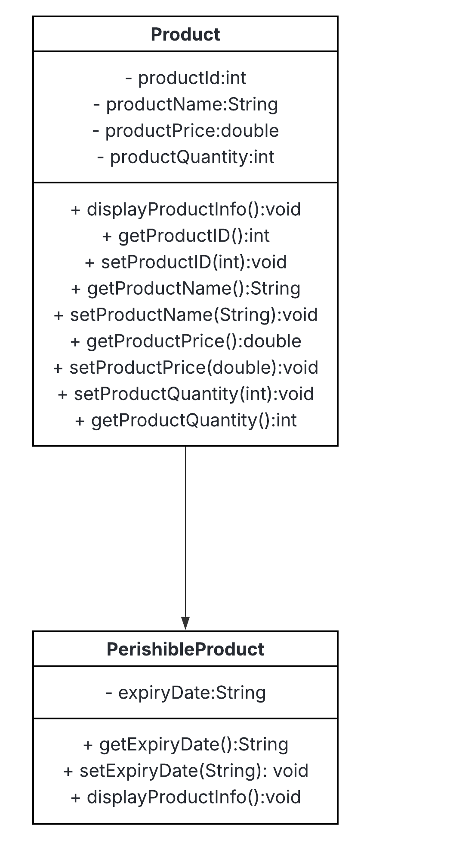
Each product has a unique ID, a name, a selling price, and the quantity available in the inventory. It has a parameterized and a default constructor, that creates a product.
It also extends the PerishibleProduct class, which inherits all attributes and methods of the Product class. It has its own additional attribute, expiryDate, which contains the expiration date of the product.
The method from the Product class, displayProductInfo(), gets overridden if it is expired.
- InventoryManager Class:
Manages all inventory operations with add, view, update, delete or search a product.
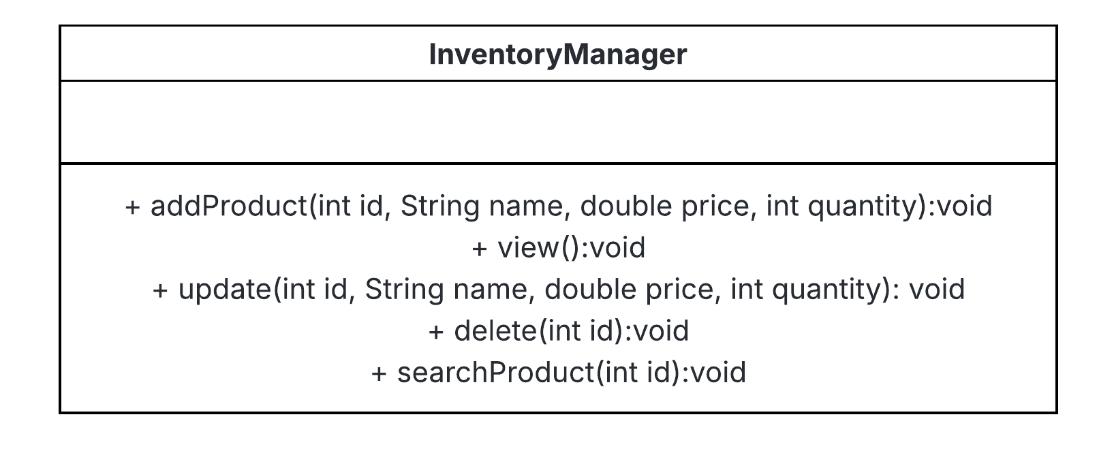
Has no attributes but has a fixed-size array for storing the products, and the methods for operating the product.
- Main Class
Handles the user interactions and the menu layout.
